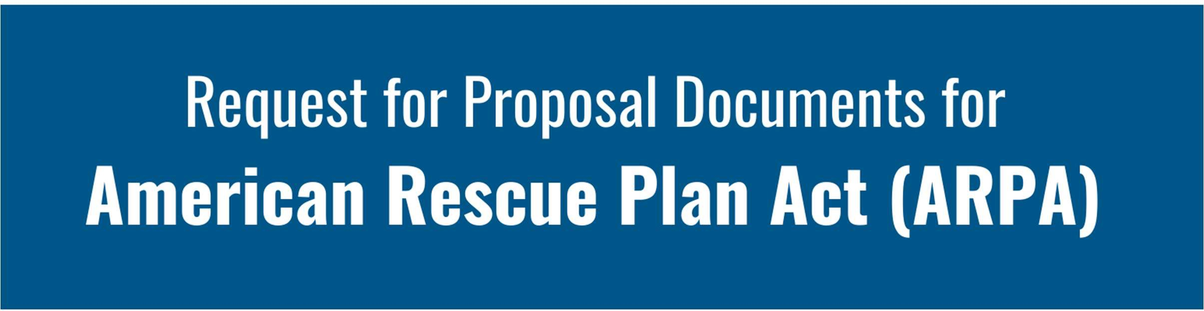

Mental Health Support Programs and Services


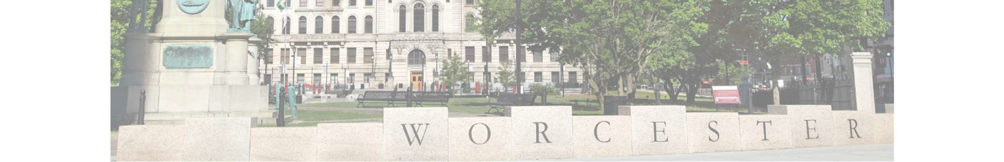

TABLE OF CONTENTS

- Part I – ARPA Program Background and Eligible Applicants and Beneficiaries 1
  - Qualifying Eligible Beneficiaries and Populations 3
  - Services and Activities Solicited 8
  - General Applicant Registration and Threshold Requirements for Program…………………………..10
  - Key Disclosures and Notices 11
- Part II – Program Policies and Regulations…………………………………………………………………………12
  - Post-Award Grant Administration and Reporting Requirements 13
  - Policies of Program……………………………………………………………………………………………………………...15
  - ARPA Specific Compliance and Further Guidance 15
  - Required Federal Regulations 16
  - Additional Applicable Regulations 17
- Part III –Mental Health Support Programs and Services Applicant Information…......19
- Part IV – Statement of Applicant, Application Checklist of Required Documents 25
  - Statement of Applicant 25
  - Application Checklist of Required Documents 26
- Part V – Attachments 27
  - Budget Guidelines for Mental Health Support Programs and Services Budget
  - Mental Health Support Programs and Services Budget

PART I: ARPA PROGRAM BACKGROUND AND ELIGIBLE APPLICANTS AND BENEFICIARIES

ARPA PROGRAM BACKGROUND

The City of Worcester received approximately $146 million from the federal government, through the U.S Treasury, as a result of the American Rescue Plan Act (ARPA). This direct allocation is part of the Coronavirus State and Local Fiscal Recovery Funds (SLFRF) program. The goal of the SLFRF program is to ensure that state, local and Tribal governments have the resources needed to fight the pandemic, strengthen and sustain economic recovery, maintain vital public services, and make investments that support long-term growth, opportunity, and equity. The funding is intended to address local needs within these four eligible categories:

- Replacing Lost Public Sector Revenue
- Addressing Public Health and Economic Impacts
- Providing Premium Pay to Essential Workers
- Improving Water, Sewer and Broadband Infrastructure

The City administration views all the above categories as important and anticipates addressing them through multiple interdepartmental ARPA related funding streams and efforts. For a detailed overview of the City’s full ARPA budget components and overall funding strategy, please visit: http://www.worcesterma.gov/arpa. Under the “Additional Information” section, please find the PDF titled, “City Council Informational Communication on Proposed ARPA Budget – December 14, 2021”.

This Request for Proposal (RFP) is for activities and programs addressing community-based initiatives that address the eligible ARPA category of “Addressing Public Health and Economic Impacts” through Mental Health Support Programs and Services.

COMMUNITY INPUT

To better formulate and strategically apply ARPA funding resources toward community priorities, the City of Worcester hosted a series of public input/community needs sessions in the summer and fall of 2021. A total of 5 sessions were held in various locations throughout the City of Worcester and over 200 residents attended. In addition, an online survey was available on the City’s website that resulted in 331 individuals responding. The combined responses of both the public input sessions and online surveys provided over 6,000 data points that were recorded, analyzed and summarized to better understand the most urgent needs within the community. All applicants are requested to read the full and detailed results of the community input, which is available at: http://www.worcesterma.gov/arpa. Under the “Additional Information” section please see the PDF titled, “City Council Informational Communication on ARPA Community Input – November 30, 2021”.

Numerous issues were identified through the community input process, with the following emerging as top overall community needs from both the survey and community meetings:

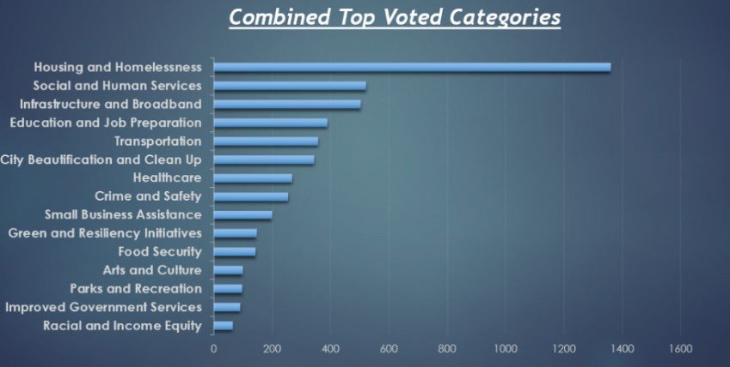

CITY OF WORCESTER PROJECT AND PROGRAM CATEGORIES

Through wholly separate RFP and funding processes, the City of Worcester will address a community-based need that responds to the public health and economic impacts of the pandemic. Additionally, each of these categories and topics will have its own Ad-Hoc Committee comprised of residents of the City of Worcester that will help the City evaluate RFP applications.

Business Assistance
Small business is the backbone of the local economy, many owned by members of the BIPOC community. The recommended programs in this category include: Business Safety Net and COVID Improvements, Technical Assistance for Small Businesses, Minority/Women Business Enterprise Fund and Marketing.

Community Projects/Programs
This category will address social and human services, as well as capital improvements, anticipated to help community-based organizations better serve impacted populations. Examples of social and human services include daycare, health care, education, job training, housing stability services, case management, food security, services for youth or elderly, transportation, social work, counseling, etc. Examples of capital upgrades include improvements, expansion and rehab work to community-based and community serving non-profit facilities.
The latter may include, but not limited to: access and safety improvements, energy efficiency upgrades, core systems improvements, other site or building improvements that help organizations to maintain and expand their services and help their staff to better or more safely serve impacted populations.

Creative Economy
The recommended programs in this category are as follows: City of Worcester Cultural Plan Implementation, Creative/Cultural Organizations and Facilities Grants and Community/Cultural Festival Support/Other.

Mental Health Programs
This category is for organizations requesting financial support for programs and services addressing mental health issues in Worcester. Proposals will be reviewed by the City's Health and Human Services Department, aligned with the work of the Mayor's Mental Health Taskforce and be recommended by the proposed Ad-Hoc Committee for this purpose.

Affordable Housing
This category is for various affordable housing initiatives throughout the city. The recommended programs in this category include: the Affordable Housing Trust Fund, Owner Occupied Rehabilitation, First Time Homeownership Development, Sustaining Housing First Solutions, Lead Abatement Program, Down Payment Assistance and Home Flood Insurance Reimbursement.

This RFP pertains only to the Mental Health Support Programs and Services category referenced above.

QUALIFYING ELIGIBLE BENEFICIARIES AND POPULATIONS

All activities solicited through this RFP must serve qualifying households and populations as described by the SLFRF ARPA funds. The U.S. Treasury’s Final Rule recognizes certain populations have experienced disproportionate health or negative economic impacts during the pandemic. This rule also explains that low-income and underserved communities often have faced more severe health and economic outcomes, such as higher rates of COVID-19 infection, mortality and unemployment because of pre-existing disparities exacerbated by the impact of the pandemic. In addition, the Final Rule states that certain services provided in a Qualifying Census Tract (QCT), or services provided to individuals living in a QCT, are also presumed to be addressing disproportionate impacts. Furthermore, the guidance allows for the local grant recipients, such as the City of Worcester, to define disproportionately impacted classes, based on research related to documented impacts of the pandemic on certain population classes as well as pandemic related socioeconomic impacts or pre-existing socioeconomic conditions for said classes.

As part of this application process, the City of Worcester will prioritize applications that create equitable outcomes by assisting disproportionately impacted communities.

LOW-INCOME QUALIFICATION

For this purpose, the U.S. Treasury defines low-income as:

- Annual household income at or below 185 percent of the Federal Poverty Guidelines for the size of its household based on the most recently published poverty guidelines; or
- Annual household income at or below 40 percent of area median income for its county and size of household based on the most recently published data.

Applying the above criteria to current income data points for the City of Worcester, the table below enumerates the different categories by household size and income that would qualify as eligible to receive ARPA funding assistance:
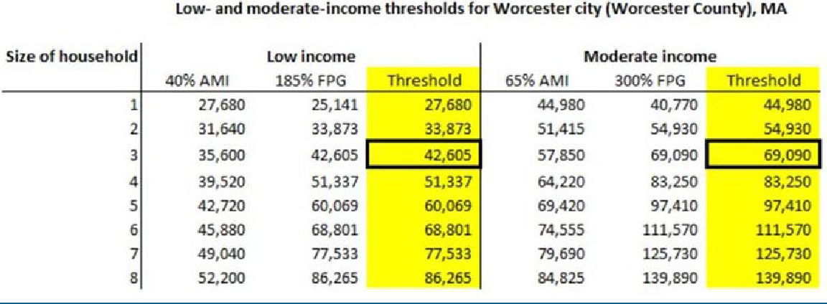
Note: When applying these thresholds, recipients should generally use the income threshold for the size of the household to be served; however, recipients may use the income threshold for a default size of three if providing services that reach a general geographic area or if doing so would simplify administration of the program to be provided. The thresholds for a three-person household are marked with boxes in the above table.

Treasury guidance allows further administrative flexibility by considering recipients of the following income restricted public programs and services as either impacted or disproportionately impacted by the pandemic, and therefore populations and households receiving them are deemed eligible beneficiaries of ARPA assistance:

- Children’s Health Insurance Program (CHIP)
- Childcare Subsidies through the Child Care and Development Fund (CCDF) Program
- Medicaid
- National Housing Trust Fund (HTF), for affordable housing programs only
- Home Investment Partnerships Program (HOME), for affordable housing programs only
- Temporary Assistance for Needy Families (TANF)
- Supplemental Nutrition Assistance Program (SNAP)
- Free and Reduced-Price Lunch (NSLP) and/or School Breakfast (SBP) programs
- Medicare Part D Low-income Subsidies
- Supplemental Security Income (SSI)
- Head Start and/or Early Head Start
- Special Supplemental Nutrition Program for Women, Infants, and Children (WIC)
- Section 8 Vouchers
- Low-Income Home Energy Assistance Program (LIHEAP)
- Pell Grants

QUALIFYING CENSUS TRACTS (QCTs):

A Qualified Census Tract is defined as any census tract in which at least 50 percent of households have an income less than 60 percent of the Area Median Income (AMI), or which has a poverty rate of at least 25 percent.

The below map is a depiction of the QCTs in the City of Worcester and populations residing in these census tracts are presumed eligible beneficiaries of ARPA funded programs and services:
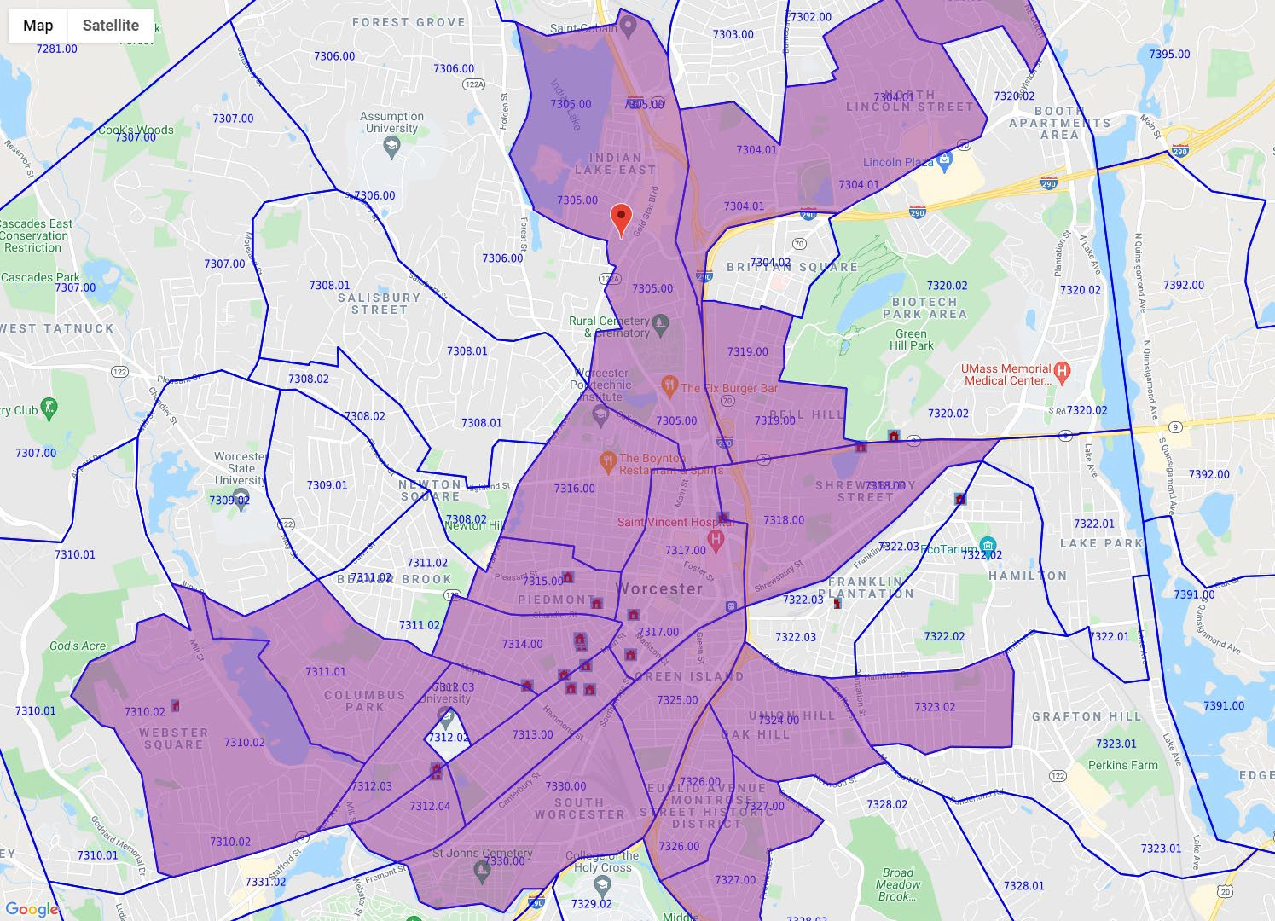

An interactive map can be accessed here: https://www.huduser.gov/portal/sadda/sadda_qct.html

- To determine your census tract, once the map is opened:
  - In the search bar at the top of the page, enter “Worcester, MA”.
  - Below “Map Options” on the left side of the screen, select:
    - Color QCT Qualified Tracts (Zoom 7+)
    - Show Tracts Outline (Zoom 11+)
o Zoom in to determine your appropriate Census Tract number (ex. 7325.00, 7317.00, etc.)

DISPROPORTIONATELY IMPACTED POPULATIONS

The Department of Treasury’s Final Rule provides additional local flexibility granted to the local recipients, such as the City of Worcester, to determine which general households or populations have been impacted and/or disproportionately impacted by the pandemic based on documented data or research. The local recipient may demonstrate that an individual household or business is within the class that experienced a negative economic impact, rather than requiring a recipient to demonstrate that each individual household or small business experienced a negative economic impact, because the impact was already identified for the class. The City of Worcester has therefore determined the following populations (cohorts of the overall city-wide population) were disproportionately impacted in the City of Worcester based on the current and pre-existing socioeconomic conditions, as well as COVID pandemic specific public health impacts, and are therefore are presumed eligible beneficiaries * :

- Hispanic/Latino Population
- Black/African-American Population
- American Indian/Alaska Native Population

The above referenced populations were more disproportionately impacted, in general, than the overall population and the White population, in particular. This conclusion is based on an analysis of statistics and data from the following sources: U.S. Decennial Census, 2020 U.S. Census American Community Survey (ACS), 2018 U.S. Department of Housing and Urban Development (HUD) Comprehensive Housing Affordability Strategy, 2019, 2020, and 2021 U.S. Bureau of Labor Statistics, and UMass Memorial Healthcare statistics collected for all of the City of Worcester’s COVID positivity and hospitalizations. The narrative below explains further and is a narrative with highlights from said analysis.

Hispanic/Latino Population

The City’s Hispanic/Latino population was disproportionately impacted by the COVID-19 pandemic, and had exhibited a host of socioeconomic challenges and conditions prior to the pandemic that appear to have been further exacerbated following the pandemic onset.

University of Massachusetts Memorial Healthcare data shows City of Worcester COVID positivity rates for the Hispanic/Latino population, between March 11, 2020 through January 30, 2022, was two-thirds, or 66% higher, than the proportional impact within the City’s White population. Similarly, the COVID positive hospital admission rate was well in excess of twice the rate, or 138% higher, the proportional rate of hospitalizations for the City’s White population.

In 2020, the Median Household Income (for 2 or more related persons) was noticeably lower than the comparable city- wide Median Household Income (MHI) and less than half the level ( -54.4%) of the MHI for the City’s White population. Prior to the pandemic, in 2019, the Hispanic/Latino population had 48.3% higher rate of unemployment than the similar unemployment rate for the City’s White population. Following the onset of the pandemic, in 2021, the unemployment rate became almost twice that of the proportional rate for the City’s White population, or 98% higher, while also

experiencing a more than doubling increase in proportional unemployment relative to the City as whole: moving from 19.4% to 42.3% higher unemployment rate than the City as whole.

Comprehensive Housing Affordability Strategy (CHAS) data used by the U.S. Department of Housing and Urban Development (HUD) for 2018 indicates that the Housing Cost Burden (% of households spending over 30% of income on housing) for the Hispanic/Latino population was 42.3% higher than the comparable burden for the City of Worcester’s White population. Similarly, the City’s Hispanic/Latino population had lower proportional rates of housing unit ownership than the City population as a whole, as well as when compared to solely the White population. In 2020, the Hispanic/Latino population had a 64.0% higher proportional rental unit occupancy rate than the City’s White population, implying a lower homeownership rate amongst the Hispanic/Latino population.

Black/African-American Population

The City of Worcester’s Black/African American population was disproportionately impacted by the COVID-19 pandemic, and had a host of socioeconomic challenges and conditions prior to the pandemic that appear to have been further exacerbated following the pandemic onset.

University of Massachusetts Memorial Healthcare data shows City of Worcester COVID positivity rates for the Black/African American population, between March 11, 2020 (effectively near the onset of the pandemic) through January 30, 2022, was over a third, or 38% higher, than the proportional impact within the City’s White population. Similarly, the COVID positive hospital admission rate was almost 40% higher (39.3%) than the proportional rate of hospitalizations for the City’s White population.

In 2020, the Median Household Income (for 2 or more related persons) was noticeably lower than the comparable city- wide Median Household Income (MHI) and almost a third lower ( -38.6%) than the MHI for the City’s White population. Prior to the pandemic, in 2019, the Black/African American population had a 27.6% higher rate of unemployment than the similar unemployment rate for the City’s White population, and following the onset of the pandemic, in 2021, the unemployment rate became 78.4% higher than that of the City’s White population, while also experiencing a ten-fold increase in proportional unemployment relative to the City as whole: moving from 2.8% higher to 28.2% higher unemployment rate than the City as whole.

Comprehensive Housing Affordability Strategy (CHAS) data used by the U.S. Department of Housing and Urban Development (HUD) for 2018 indicates that the Housing Cost Burden (% of households spending over 30% of income on housing) for the Black/African American population was 47.1% higher than the comparable burden for the City of Worcester’s White population. Similarly, the City’s Black/African American population had lower proportional rates of housing unit ownership than the City population as a whole, as well as when compared to solely the White population. In 2020, the Black/African American population had a 48.8% higher proportional rental unit occupancy rate than the City’s White population, implying a lower homeownership rate amongst the Black/African American population.

American Indian/Alaska Native Population

The City of Worcester’s American Indian/Alaska Native population was also disproportionately impacted by the COVID- 19 pandemic, and also was beset by socioeconomic challenges and conditions prior to the pandemic that appear to have been further exacerbated following the pandemic onset.

University of Massachusetts Memorial Healthcare data shows City of Worcester COVID positivity rates for the American Indian/Alaska Native population, between March 11, 2020 through January 30, 2022, was over a third, or 38% higher, than the proportional impact within the City’s White population. Similarly, the COVID positive hospital admission rate was almost twice the rate, or 193.4% higher, than the proportional rate of hospitalizations for the City’s White population.
In 2020, the Median Household Income (for 2 or more related persons) was noticeably lower than the comparable city- wide Median Household Income (MHI) and more than -43.8% lower than the MHI for the City’s White population. Prior to the pandemic, in 2019, the American Indian/Alaska Native population had an almost 37.9% higher rate of unemployment than the similar unemployment rate for the City’s White population, and following the onset of the pandemic, in 2021, the unemployment rate became 58.8% higher than that of the City’s White population.

Comprehensive Housing Affordability Strategy (CHAS) data used by the U.S. Department of Housing and Urban Development (HUD) for 2018 indicates that the Housing Cost Burden (% of households spending over 30% of income on housing) for the American Indian/Alaska Native population was 67.8% higher than the comparable burden for the City of Worcester’s White population. Similarly, the City’s American Indian/Alaska Native population had lower proportional rates of housing unit ownership than the City population as a whole, as well as when compared to solely the White population. In 2020, the American Indian/Alaska Native population had a 72.6% higher proportional rental unit occupancy rate than the City’s White population, implying a lower homeownership rate amongst the American Indian/Alaska Native population.

*Note: Terminology referencing race and ethnicity is that utilized by the US Census and other data sources, and as required by the federal Office of Management and Budget.

SERVICES AND ACTIVITIES SOLICITED

This RFP will address mental health support programs and services anticipated to help community-based organizations
better serve impacted populations. Applicant Organizations that serve under insured people or people with no insurance
on a pro-bono basis are encouraged to apply.
Examples of each activity are shown below. This list of potential proposals is non- exhaustive, and additional projects and programs as proposed by applicants will be considered:

MENTAL HEALTH SUPPORT PROGRAMS AND SERVICES

- High quality, affordable and culturally competent mental healthcare in the context of supporting childcare and early learning services, including but not limited to: home visiting programs, services for child welfare-involved families and foster youth, programs to improve children’s access.
- Improvements in school and student services, including but not limited to: behavioral health services to address academic, social, emotional and mental health needs in high-poverty school districts, safe and modernized facilities, additional supplies and equipment, culturally appropriate peer groups, comprehensive community mental health services for children.
- Programs to assist expectant mothers with substance use disorders, mental health and emotional needs, including but not limited to: services for pregnant women or infants born with neonatal abstinence syndrome, adjunct services to maintain engagement with and facilitate long-term recovery for pregnant women and women with dependent children throughout the substance use continuum of care.
- Workforce capacity building for service providers, including but not limited to: certifications and assistance for professional development around best practices in general, as well as the more culturally competent and trauma informed service providers, including promoting development of more diverse and inclusive service providers.
- Support to help bridge the technological divide/gap and support for those in isolation or quarantine, including but not limited to: providing hardware, providing training, on-going relationship and assistance, one-on-one help, especially for elders, systems for telehealth / teledoc, behavioral health services, connecting with therapists, connecting socially with others to lessen social isolation.
- Expansion of access to evidenced-based services for opioid use disorder prevention, treatment, harm reduction, and recovery; support and programs for people living with substance use disorder and/or in recovery housing, including but not limited to: case management, supplements to or alternatives to traditional 12 step program, recovery coaches that are culturally competent, programs to help with prevention, youth substance abuse, alternative pathways to divert from criminal justice system, re-entry programs and support services for recently incarcerated.
- Culturally aware and peer oriented support groups and services, including but not limited to: culturally inclusive affinity groups, culturally sponsored/led groups.
- Suicide Intervention and Crisis Prevention, including but not limited to: school based clinicians / screening / services, training for everyday people on how to notice and respond, peer response and peer training for responding in a non-clinical way, clinicians responding to 911 calls / attending site visits with EMTs, mental health training and response for first responders, in-home support programs for clinically suicidal.

GENERAL APPLICANT REGISTRATION AND THRESHOLD REQUIREMENTS FOR PROGRAM

BASIC THRESHOLD REQUIREMENTS

Applicants interested in applying for ARPA funds must:
- Have an activity or program that addresses a local need and meets the eligible category of “Addressing Public Health and Economic Impacts” and responds to the needs of the City of Worcester, as documented in the ARPA Community Input referenced previously in Part One of this RFP;
- Be eligible to participate in Federal, state and locally-funded programs;
- Register on Sam.gov and obtain and Unique Entity Identifier (UEI)
- Have a functioning accounting system and protocols that are operated in accordance with generally accepted accounting principles, or have designated an entity that will maintain such an accounting system; and
- Be a 501(c)(3) with a Board of Directors or be able to provide accountant produced financials.
- Provide a current budget for the proposed project or program
- Applicant and its affiliates or subsidiaries must be current in all financial obligations with the City of Worcester. The City of Worcester will not fund an organization or agency with defaulted loans, tax arrearages, debarment actions or any other legal encumbrances, regardless of the merits of the submitted proposal.

VENDOR AND SAM.GOV REGISTRATION

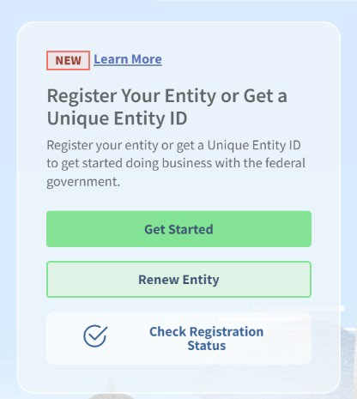All entities that receive a federally funded contract must be registered in the System for Award Management (SAM.gov)

In order to begin registration, please visit SAM.gov | Home. Once there, on the right- hand side, you will see a window for registering your entity or to get a Unique Entity Identifier (UEI Number).

Once you click on the ‘Get Started’ tab, the website will walk you through the steps for completing the process. Please note, it may take multiple weeks for the system to register your entity so it is advised to start this process as soon as possible. Applicants that are still waiting for their registration to be processed will not be disqualified, but will not be able to receive a grant contract until it’s complete.

KEY DISCLOSURES AND NOTICES

- The RFP documents contained herein do not commit City of Worcester to make an award, execute a contract, or pay for costs incurred in the preparation of said RFP, or to procure or contract for a program or service in connection therewith. The City of Worcester reserves the right to accept or reject any or all proposals received through this RFP, or cancel in part or in its entirety this Request for Proposals.

- The City may seek to obtain further information from any and all respondents and potentially waive any defects to form or content of RFP or any responses by the applicant organization(s); applicants may be required to make one or more presentations before administrative staff or an advisory committee, and/or asked to participate in interviews.

- Pursuant to 2 CFR 200.205, all RFP applicants may be subject to pre-award risk assessment as part of the City of Worcester’s overall decision making process related to making sub-awards stemming from this RFP process. The risk assessment may involve, at a minimum, evaluating risks posed by RFP applicants related to the following parameters: financial stability, quality of management systems, ability to meet the management standards, and history of past grant performance, to include the applicant's record in managing prior Federal awards.

- Pursuant to 2 CFR 180, prior to making any awards and contracts for ARPA funded programs or services, the City of Worcester will conduct a suspension and debarment check to ensure any sub-awards and contracts are not executed with parties that have been debarred, suspended or otherwise excluded from or ineligible for participation in Federal programs or activities.

- RFP applicants must abide by the City of Worcester’s Conflict of Interest policy. Items of concern would include staff members serving on the Board of Directors, staff members’ families serving on the Board of Directors, and other matters that may give the appearance of a conflict of interest.

- Any SLFRF funds awarded through this RFP process may not be used to fund inherently religious activities such as worship, religious instruction, or proselytization.

- False statement or misrepresentations in RFP documents, or subsequent award contract documents, may automatically disqualify applicants and/or result in immediate repayment of federal funds to the City of Worcester.

- Upon submittal to the City of Worcester, all RFP documents become Public Record and property of the City of Worcester.

PART II: PROGRAM POLICIES AND REGULATIONS

APPLICATION DEADLINE AND SUBMISSION DETAILS

Applications will become available on Tuesday, January 17, 2022, and will be due to the City of Worcester’s Executive Office of Economic Development by no later than 5:00 PM on Friday, March 3, 2023.

There are $2 million SLFRF funds to support Mental Health Support Programs and Services, in order to ensure that this funding reaches as many disproportionately impacted individuals as possible, we are limiting the amount of applications one agency can submit to no more than two (2) RFP applications.

RFP EVALUATION AND SELECTION PROCESS

All RFP applications will be evaluated on their merits and the program eligibility of the proposals by the City administration using set scoring rubrics that take into account many factors, including but not limited to:

- Overall community and community mental health need(s) addressed
- Nature, level, and quality of service to disproportionately impacted populations
- Prior experience delivering similar or comparable services/programs
- Cost reasonableness
- How well the application addresses issues of equity in the community
- Project readiness
- Use of best practices
- Sustainability
The City administration also anticipates utilizing community advisement and input from an ad-hoc citizen advisory committee representing the Mental Health Support Programs and Services funding category throughout the RFP evaluation process. The committees consist of six (6) community members appointed by former City Manager Ed Augustus. Prior to appointment, committee members were selected through an extensive application and interview process that included a review panel comprised of administrative staff from departments affiliated with the specific funding categories and two (2) members of the community based logistics committee of the Worcester Together Initiative.

POST-AWARD GRANT ADMINISTRATION AND REPORTING REQUIREMENTS

The City of Worcester, and by default any RFP applicants who are ultimately awarded ARPA funds through this RFP process, will be required to adhere to all requirements for federal funding and federal grant awards as expressed in the ARPA Final Rule, as well as based on the full cluster of all applicable federal grant regulations, primarily including, but not limited to, 2 CFR 200, and any other local or state requirements that may pertain to the specific project or program funded through this RFP application.

Below are expected minimum thresholds that will apply to the majority of ARPA federal grants sub-awards provided by the City of Worcester to any sub-recipients through this RFP process.

MINIMUM AND MAXIMUM AWARD AMOUNTS

All funding allocated to any awarded projects or programs through this Request for Proposal process will be contingent on SLFRF funding available to the City of Worcester at time of award making. All awards will be based on funding requests as itemized in the project/program budget(s) required as part of this application. Awards are anticipated to not exceed the requested application amount(s), as well as not fall short of a requested amount so as to not significantly compromise the proposed activity or program. The City’s SLFRF funds are finite, so maximum award caps for any single request have also been established. The following are the caps for minimum and maximum awards in each Mental Health Support Programs and Services category:

- Awards for Mental Health Support Programs and Services will be no less than $5,000 for any single application/program, and no single application/program award is to exceed $250,000.

GRANT AGREEMENTS

All RFP applicants that are ultimately chosen to receive ARPA funding awards through this RFP must enter into a grant agreement/contract with the City of Worcester for use of said funds. The grant agreement will contain requirements and expectations around grant draws, reporting, and all federal and state regulations, citations, and provisions for grant compliance

SCHEDULE FOR USE OF FUNDING

The City of Worcester must have all ARPA related funds obligated by December 31, 2024, and fully expended by December 31, 2026.

No funding will be disbursed to an ARPA grant sub-recipient unless there is a grant contract in place between the City of Worcester and the respective sub-recipient. Any applicants awarded funds through this RFP process will be subject to specific grant funding disbursement and project/program completion dates, memorialized in any grant agreement/contract for ARPA funds executed between the sub-recipient and the City of Worcester. Contracts will also

stipulate regular performance-based reporting requirements to include reporting on contracted grant activity goals and metrics before any grant draw or reimbursement requests can be approved by the City of Worcester.

PERIOD OF PERFORMANCE

Mental Health Support Programs and Services will bound by the following general expectations according to their respective category:

- The period of performance for Mental Health Support Programs and Services should reflect a 1 year or 2 year (max) project/program implementation timeframe from time of contract or commencement of activity, whichever is deemed more applicable or necessary. The Budget form will have you designate a 1 year or 2 year program.
- All Mental Health Support Programs and Services awarded SLFRF funding through this RFP process will have the period of performance memorialized in their grant agreements with the City of Worcester.
- ALL grants awarded to subrecipients through this RFP process must be fully expensed and/or completed before the federal deadline of December 31, 2026.

REPORTING AND MONITORING REQUIREMENTS

As a City of under 250,000 in population that has received more than $10 million in ARPA related funding, the Final Rule for SLFRF funds under ARPA requires that the City of Worcester report on expenditures by providing quarterly project and expenditure reports due within 30 days after each quarter.

All applicants that are awarded ARPA funding through the City of Worcester will be required to submit necessary reports on activities, programs, and services by including accomplishment data as necessary and as needed to, at minimum, assist in the City’s above obligations in reporting grant expenditures and outcomes to the federal government as described above. Reporting requirements will be dependent on the nature and type of program proposed and defined in the contract for use of SLFRF funding. Reporting is generally expected to be on a quarterly or bi-annual basis, oriented to documented/reported outcome schedule.

Grant sub-recipients are expected to be monitored by the City of Worcester during the grant funded activity’s project term and grant sub-recipient monitoring expectations may vary based on any pre-contract risk assessment analyses completed by the City of Worcester prior to contracting.

FUND DISBURSEMENT AND DRAW SCHEDULES

All SLFRF awards resulting from this RFP process will have expenditure and draw schedules defined within each City of Worcester contract/agreement for use of said funds. Funding is generally expected to be reimbursement in nature and pursuant to the reporting cycle and requirements for each program or project being funded. Expenses will only be approved through City of Worcester receipt of documented/reported outcomes pursuant to their contracted schedule (i.e. monthly, quarterly, bi-annually, etc.) and as related to the program’s cost per unit to provide service to a beneficiary.

All awarded and contracted program activities will have a 10% of their overall award/program budget retained, with disbursement of said retainage contingent on final completion of contracted programmatic outcomes, including any and all associated final reporting associated with the grant outcomes.

Advanced Funding: Mental Health Programs and Services
Reimbursement is the standard method for fund disbursement, however, for grant awards under $50,000, advanced disbursements or “forward funding,” in lieu of a reimbursement model, is allowable if pursuant to conditions and stipulations articulated in 2 CFR 200.305 (b)(1) , whereby requested funds are limited to the minimum amounts needed and timed to be in accordance with the actual, immediate cash requirements of the subrecipient to carry out the purpose of the approved program or project. All aforementioned advanced funding request scenarios must be substantiated and documented to the City of Worcester by the subrecipient prior to any forwarded/advanced funding approval.

POLICIES OF PROGRAM

- Compliance with federal and state laws requiring the safeguarding and disclosure of confidential information
- Evidence of comprehensive liability insurance as may be required by the City
- Completion of an annual financial audit, and/or as applicable, providing the City with a copy of the organization’s accountant prepared financial statement
- Completion and subsequent renewal of background checks for all employees, volunteers, or interns who will or may have unsupervised contact with children or vulnerable adults
- Maintaining program and financial records for audit review, providing access to documentation upon request by the City as needed, and submission of program reporting and financial reports as required by the City
- Registration of entity is required on Sam.gov to bid on federal contracts as a prime contractor or seek federal assistance as a prime awardee. Once registered, you will be assigned a Unique Entity ID (UEI).
- Certification that the applicant entity is not bankrupt or under an administration appointed by the Court, or under proceedings leading to a declaration of bankruptcy; and provide any pending or known legal actions against the company
- State & Federal Tax Exemption Determination Letters, as applicable
- List of Board of Directors, their Titles and Contact Information for 501(c)(3) organizations, as applicable

ARPA SPECIFIC COMPLIANCE AND FURTHER GUIDANCE

Below, please find resources that provide additional background of the Coronavirus State and Local Fiscal Recovery Funds (SLFRF) and information regarding the compliance and reporting requirements of this law.
- U.S. Treasury Website - Coronavirus State and Local Fiscal Recovery Funds

- ARPA Fact Sheet 2021
- Overview of the Final Rule
- Compliance and Reporting Guidance
  - Part One: General Guidance
  - Part Two: Reporting Requirements
- FAQ Guidance

Non-profit organizations that receive ARPA funding for ARPA-eligible activities are also subject to 2 CFR Part 200 - Uniform Administrative Requirements, Cost Principles, and Audit Requirements for Federal Awards, also referred to as the “Super Circular”. The Super Circular supersedes federal guidance and regulations formally found in OMB Circular A- 122, Cost Principles, OMB Circular A-133, Audits, OMB Circular A-87, and OMB Circular A-110, Uniform Administrative Requirements.
For additional information regarding definitions, eligibility considerations, and more, applicants are encouraged to consult the U.S. Treasury’s Final Rule or Overview, which are available at the City of Worcester’s website at the below link under “Additional Information”: http://www.worcesterma.gov/arpa.

REQUIRED FEDERAL REGULATIONS

2 CFR PART 200 - KEY SECTIONS

- Subpart B – General Provisions (§ 200.112-113)

Subpart C – Pre-Federal Award Requirements and Contents of Federal Awards
  - § 200.201 (3) – Use of Grant Agreements (including fixed amount awards), Cooperative Agreements, and Contracts
  - § 200.206 (b) – Risk Evaluation
  - § 200.207 - Standard Application Requirements
  - § 200.214 - Suspension and Debarment

Subpart D - Post Federal Award Requirements
  - § 200.300 (b) – Statutory and National Policy Requirements
  - § 200.301 – Performance Measurement
  - § 200.303 – Internal Controls
  - § 200.308 – Revision of Budget and Program Plans
  - § 200.310 – Insurance Coverage
  - § 200.311 – Real Property
  - § 200.313 - Equipment
  - § 200.314 - Supplies
  - § 200.318 - § 200.327 – Procurement Standards (Sections 200.317 – 200.327)

  - § 200.328 – § 200.330 – Financial Monitoring and Reporting
  - § 200.339 – Remedies for Noncompliance

Subpart E - Cost Principles
  - § 200.404 – Reasonable Costs
  - § 200.405 – Allocable Costs
  - § 200.413 – Direct Costs
  - § 200.414 – Indirect Costs
  - § 200.415 – Required Certifications

Selected Items of Cost lists not allowed include:
  - § 200.421 - Advertising and public relations
  - § 200.422 – Advisory Councils
  - § 200.423 - Alcoholic beverages
  - § 200.425 – Audit Services
  - § 200.426 – Bad Debts
  - § 200.427 – Bonding Costs
  - § 200.434 - Contributions and donations
  - § 200.438 - Entertainment costs
  - § 200.441 – Fines, Penalties, Damages and Other Settlements
  - § 200.445 – Goods or Services for Personal Use

Subpart F – Audit Requirements
  - § 200.501 – Audit Requirements

Appendix XII to Part 200 – Award Term and Condition for Recipient Integrity and Performance Matters

ADDITIONAL APPLICABLE REGULATIONS

The items listed below are additional regulations and policies that may pertain to this funding request as applicable and necessary depending on nature of program activity and full-nature of all funding sources used for the project or program.
- 31 CFR Part 35 – Pandemic Relief Programs – Determines eligibility of activity
- 2 C.F.R. Part 25 - Universal Identifier and System for Award Management (SAM). Pursuant to the granting of federal funds, all non-federal entities must register on SAM.gov.
- Davis-Bacon and Related Acts – the Davis-Bacon and Relating Acts require contractors and sub-contractors, which receive federal funds for construction, alterations or repairs, to pay their laborers no less than local prevailing wages. (***for programs that combine ARPA funding with other grant sources)

- 2 C.F.R. Part 180 - OMB Guidelines to Agencies on Government-wide Debarment and Suspension (Non- procurement)
- 31 C.F.R. Part 20 - Government-wide Requirements for Drug-Free Workplace
- 31 C.F.R. Part 21 - New Restrictions on Lobbying
- 42 U.S.C. §§ 4601-4655 - Uniform Relocation Assistance and Real Property Acquisitions Act of 1970 and
implementing regulations.
- 24 CFR 50 and 24 CFR 58 - Completion of an environmental review (for programs that combine SLFRF funding with other grant sources whereby necessary or applicable)
- These statutes and regulations prohibit discrimination and are applicable to this award:
  - Title VI of the Civil Rights Act of 1964 – Non-discrimination in federally assisted programs
  - 42 U.S.C. §§ 2000d - Prohibits discrimination to housing on the basis of race or color, religion, sex, national origin, family status or disability
  - 31 C.F.R. Part 22 - Nondiscrimination on the basis of race, color, or national origin in programs or activities receiving federal financial assistance from the Department of the Treasury
  - 42 U.S.C. 3601 - The Fair Housing Act, Title VIII of the Civil Rights Act of 1968 (42 U.S.C. §§ 3601 et seq.), which prohibits discrimination in housing on the basis of race, color, religion, national origin, sex, familial status, or disability
  - Section 504 of the Rehabilitation Act of 1973, as amended (29 U.S.C. § 794) - Prohibits discrimination on the basis of disability under any program or activity receiving federal financial assistance
    - Title II of the Americans with Disabilities Act of 1990, as amended (42 U.S.C. §§ 12101 et seq.), which prohibits discrimination on the basis of disability for participating in
programs, activities, and services provided or made available by state and local governments or
instrumentalities or agencies
  - The Age Discrimination Act of 1975, as amended (42 U.S.C. §§ 6101 et seq.), and 31 C.F.R. Part 23 - Prohibits discrimination on the basis of age for participating in programs or activities receiving federal financial assistance
  - Equal Employment Opportunity Act – Prohibits workplace discrimination
  - Equal Credit Opportunity in Housing Act – Prohibits creditors from discriminating against applicants on
the basis of race, color, religion, national origin, sex, marital status, and age
- Lead Based Paint – Compliance and enforcement
- Federal Funding Accountability and Transparency Act Subaward Reporting System (FSRS) – Requires disclosure of all entities and organizations receiving over $25,000 in federal funds through a USASpending.gov
- Hatch Act – Ensures federal programs are administered in a non-partisan fashion by limiting certain political activities of federal employees.
- MGL Chapter 30 B – Uniform Procurement Act

PART III: GENERAL APPLICANT INFORMATION (ALL APPLICANTS REQUIRED TO COMPLETE)

Applicant Legal Name (Individual or Organization): | Click or tap here to enter text.
Applicant UEI: | Click or tap here to enter text.
Applicant UEI Affiliated Name (if different from Legal Name): | Click or tap here to enter text.
Applicant Primary Address: | Click or tap here to enter text.
Applicant Primary Point of Contact Name: | Click or tap here to enter text.
Applicant Primary Point of Contact Email Address: | Click or tap here to enter text.
Applicant Primary Contact Phone Number: | Click or tap here to enter text.
Does the applicant utilize a Fiscal Agent? If yes, please list the Fiscal Agent and contact information. (Please Note: Applicants that do not have the internal staffing capacity or systems in place to properly administer the fiscal/fiduciary/accounting or reporting responsibilities of federal grants are strongly encouraged to seek fiscal agent partnerships. Similarly, partnerships in general can help to amplify and diversify the beneficial impacts of grant programs and projects, and therefore collaborative applications are encouraged where they are able to provide programmatic and administrative benefits.)
Click or tap here to enter text.

What is the amount City of Worcester SLFRF ARPA funds you are requesting through this application?
$ Click or tap here to enter text.
(NOTE: Please see Part II regarding minimum and maximum award amounts; all Mental Health Support Programs and Services proposals, and their associated application budgets, should be constructed for a 1 year or 2 year (max) implementation timeframe and no more than $250,000 will be awarded per any one individual proposal/application, irrespective of program timeframe chosen.)
How much of the above funds are required for the first (6) months of the proposed program?
Click or tap here to enter text.

Has the applicant (or any partnering organization as part of this application) applied for other City of Worcester SLFRF funds as part of this application round? If so, please specify how much and for what activity/program?
Click or tap here to enter text.

Is the proposed ARPA-funded program or service located in, or does it benefit individuals in, a Qualified Census Tract? If so, please explain and identify the Census Tract.
Click or tap here to enter text.

Does the proposed ARPA-funded activity assist communities or populations impacted or disproportionately impacted by the pandemic as described in Part I of this application? Please briefly explain.
Click or tap here to enter text.

Please be detailed but brief. Do not exceed 350 words, or 2,350 characters, per question.

1. Summary of the Proposed Program/Service. Please provide a brief summary of the proposed activity. Make sure to address important items such as: description of organization/applicant, the need or purpose for the
program/service being proposed, description of primary clientele or beneficiaries, expected benefits or outcomes, and estimated timeframe for completion of activity.
Click or tap here to enter text.
2. Demonstration of Need. Provide a description of the community need the proposal is intended to address, including the extent of the need and its intended benefit to the population or community being served. Include
the estimated number of persons to be served and the characteristics of the affected population.
Click or tap here to enter text.
3. Measurable Program Outputs and Outcomes. Define specific and measurable outputs or outcomes and the method for tracking them, including data relevant to the number of individual clients or households to be
served through the ARPA funds- provide the unduplicated number of families/ persons that will benefit from the activity in one ARPA program year, and the cost per unit of service to a beneficiary. See Budget

Template attachment. Applications that do not include completed budget template forms may be
deemed incomplete and therefore potentially disqualified.)
Click or tap here to enter text.
4. Best Practices. Describe the programmatic “Best Practices” your organization will use to provide the most impactful or transformative benefits to disproportionately impacted communities. Explain how program or service will be truly meaningful or impactful. Cite evidence based or research proven methods if applicable.
Explain how the method of delivery follows the latest policies or protocols for that type of service.
Click or tap here to enter text.
5. Sustainability. Is this program or service intended to meet a short-term need brought on by the pandemic, or a long-term need? How might the proposed program be sustained once SLFRF funds are exhausted? Describe
transition or program sustainability plans, if applicable.
Click or tap here to enter text.

6. Organizational Capacity and Capability. Describe your organization’s experience and qualifications for performing the proposed work. Describe the agency’s past experience in administering programs for similar populations. List your organization’s key staff or volunteers and their roles/duties.
Click or tap here to enter text.
7. Prior Grants Management Experience. Has applicant received any public or private grants in the past, and were those funds fully expended and were all program outcomes achieved?
Click or tap here to enter text.

8. Demonstration of SLFRF Funding Need & Leveraging. Describe why funds from this grant are critical to the implementation of the proposal. Describe other revenue sources for the delivery of the proposed program or service including non-SLFRF funds that have been obtained for the project. The other funding sources should also be itemized in the Budget submitted with this proposal. Applications/proposals that
demonstrate leveraged funds will be viewed favorably, but leveraged funding is not necessarily required.
Click or tap here to enter text.

PART IV: STATEMENT OF APPLICANT AND APPLICATION CHECKLIST OF REQUIRED DOCUMENTS

STATEMENT OF APPLICANT

The undersigned acknowledges the following:
- That, to the best of its knowledge and belief, all factual information provided is true and correct and all estimates are reasonable.
- On submission of this application, the organization agrees to abide by the Federal regulations applicable to this program as well as the City’s locally established policies and guidelines.
- That past program outcomes and financial performance will be considered in reviewing this application.
- That, if the project is funded, the City or a designated agency may conduct an accounting system inspection to review internal controls, including procurement and uniform administrative procedures, prior to issuance of payments for projected expenditures.
- That, if the project is funded, the City will perform an Environmental Review, if necessary per Federal regulations, prior to the obligation of funds.
- That a project’s funding does not guarantee its continuation in subsequent funding.
- That proof of insurance (general comprehensive public liability insurance with a company licensed to do business in Massachusetts, and in the aggregate naming the City, its employees and agents as additional insures) will be submitted to the city prior to execution of the contract.
- Applicant shall provide written signatory authority from the organization’s governing body indicating who has authority to execute contracts and amendments on its behalf, prior to execution of the contract.
- Applicant agrees to abide by the City of Worcester’s Conflict of Interest policy. Items of concern would include staff members serving on the Board of Directors, staff members’ families serving on the Board of Directors, and other matters that may give the appearance of a conflict of interest.
- That, if the project(s) is funded, the organization will repay to the City any funds expended on costs consequently disallowed by the City or the Federal Government due to ineligibility based on programs rules and regulations.

PENALTY FOR FALSE OR FRAUDULENT STATEMENT
U.S. Code Title 18, Section 1001, provides that a fine of up to $10,000 or imprisonment for a period not to exceed five years, or both, shall be the penalty for willful misrepresentation and the making of false, fictitious statements, knowing same to be false.

By signature below, the Applicant acknowledges the above on this
Click or tap here
day of , 2023.
Click

Click or tap here to enter text. |  | Click or tap here to enter text. |  | Click or tap here to enter text.

Certifying Representative for Applicant Signature
Title Organization

Note: "Certifying Representative," means the individual who may legally sign this proposal on behalf of the agency and submit it to the City of Worcester.
Preparer’s Signature
Title
Organization
Click or tap here to enter text.
Click or tap here to enter text.
Click or tap here to enter text.

APPLICATION CHECKLIST FOR REQUIRED DOCUMENTS

The following documents in compliance with City, State and Federal regulations must be submitted as part of your application package. Please use this checklist as a guide to complete your proposal. Place a checkmark by the items included in the proposal. If you feel the item does not apply to your proposal, please indicate with "N/A” in the comments column and provide explanation within the comments column.

DESCRIPTION | YES | NO | COMMENTS
1. Application Fully Completed (including  mandatory budget attachment) | ☐ | ☐ | Click or tap here to enter text.
2. Signed Statement of Applicant | ☐ | ☐ | Click or tap here to enter text.
3. Certificate of Good Standing (see below for link)  DOR Certificate of Good Standing and/or Corporate Tax Lien Waiver FAQs | Mass.gov | ☐ | ☐ | Click or tap here to enter text.
4. State & Federal Tax Exemption Determination  Letters | ☐ | ☐ | Click or tap here to enter text.
5. UEI (Unique Entity Identifier) 12 Character  Alphanumeric ID Assigned By SAM.Gov | ☐ | ☐ | Click or tap here to enter text.
6. Most Recent Organization Chart | ☐ | ☐ | Click or tap here to enter text.
7. Job Description & Resume of Each ARPA  Program Salaried Position | ☐ | ☐ | Click or tap here to enter text.
8. Financial Statement & Most Recent Audit Report | ☐ | ☐ | Click or tap here to enter text.
9. Matching Funds Commitments Documentation,  if Applicable | ☐ | ☐ | Click or tap here to enter text.
10. List of Collaborative Partners & Their Role | ☐ | ☐ | Click or tap here to enter text.

PART V: ATTACHMENTS

ATTACHMENTS
(See Below)

