Community / Cultural Festival Grant Program
INTRODUCTION AND BACKGROUND

The City of Worcester received approximately $146 million from the federal government, through the U.S Treasury, as a result of the American Rescue Plan Act (ARPA). This direct allocation is part of the Coronavirus State and Local Fiscal Recovery Funds (SLFRF) program. The goal of the SLFRF program is to ensure that state, local and Tribal governments have the resources needed to fight the pandemic, strengthen and sustain economic recovery, maintain vital public services, and make investments that support long-term growth, opportunity, and equity. The funding is intended to address local needs within these four eligible categories:

- Replacing Lost Public Sector Revenue
- Addressing Public Health and Economic Impacts
- Providing Premium Pay to Essential Workers
- Improving Water, Sewer and Broadband Infrastructure

This application is for activities and programs that meet the eligible ARPA category of “Addressing Public Health and Economic Impacts.”

Community / Cultural Festival Grants

The City of Worcester has recommended $250,000 be made available to organizations that sponsor and coordinate community and/or cultural festivals, parades and events in the city of Worcester that are outdoor, free and open to the public. Over the past two years, a number of these events were canceled due to the state of emergency and/or out of an abundance of caution. These events not only benefit city of Worcester residents, but also contribute to the travel, tourism, and hospitality industry which has been specifically cited by the federal government as an eligible ARPA activity.

Organization(s) funded through this program will receive grant assistance for covering costs related to implementing the event. The City of Worcester understands these costs can be a burden or a barrier for organizations facilitating these important community and cultural activities.

Eligible Events:
- Events that are community and cultural-centric
- Events that take place outdoors in various public spaces
- Events that are free and open to the public

Maximum Grant Amount:
Organizations may request up to $10,000 in support of their event, which must be substantiated through actual, eligible costs incurred. Events that benefit or target audiences that meet the definition of Disproportionaly Impacted Populations (as defined below) may request up to $12,500.

Eligible Expenses:
Eligible Expenses include costs related to implementing the event, including City of Worcester permits/licenses, as well as costs incurred with private vendors specifically related to event setup and implementation. These costs can include, but are not necessarily limited to:
- Parks Permits and Related Parks Fees (staff, cleanup, trash disposal, electrical)
- Street Closure / Street Obstruction Permits
- Building / Electrical Permits
- Food Permits (for event sponsor only, not vendors)
- Portable Toilet Permits and Portable Toilet Rental Fees
- Entertainment License Fees
- Special One Day Liquor License Fees
- Sound Permits
- Parade Permits
- Propane Storage Permits
- Dumpter Permits
- Fireworks Permits
- WPD and WFD Detail
- Private vendor costs related to event setup and implementation. These costs proposed for ARPA funding will be reviewed for eligibility.

Dates of Eligible Events:
Grant funds may be used for costs incurred on or after January 1, 2022. Applications will be processed on a rolling basis until all of the funds are exhausted. Applications should not be submitted more than 12 months in advance of the event.

Additional Eligibility Requirements:
Applicants interested in applying for funds shall:

- Be a non-profit organization or association based in the city of Worcester
- Be in good standing with the city of Worcester for any outstanding financial obligations, excepting eligible expenses under this program.
Method of Funding:
- The first fifty percent (50%) of the funding may be provided in advance for upcoming events (no sooner than 60 days in advance of the event). Funding for recently passed events, and/or for the second fifty (50%) of the award will be provided on a reimbursement basis following submission of eligible costs incurred.
DISPROPORTIONATELY IMPACTED POPULATIONS:

The Department of Treasury’s Final Rule provides additional local flexibility granted to the local recipients, such as the City of Worcester, to determine which general households or populations have been impacted and/or disproportionately impacted by the pandemic based on documented data or research. The local recipient may demonstrate that an individual household or business is within the class that experienced a negative economic impact, rather than requiring a recipient to demonstrate that each individual household or small business experienced a negative economic impact, because the impact was already identified for the class. The City of Worcester has therefore determined the following populations (cohorts of the overall city-wide population) were disproportionately impacted in the City of Worcester based on the current and pre-existing socioeconomic conditions, as well as COVID pandemic specific public health impacts, and are therefore are presumed eligible beneficiaries * :

- Hispanic/Latino Population
- Black/African-American Population
- American Indian/Alaska Native Population

The above referenced populations were more disproportionately impacted, in general, than the overall population and the White population, in particular. This conclusion is based on an analysis of statistics and data from the following sources: U.S. Decennial Census, 2020 U.S. Census American Community Survey (ACS), 2018 U.S. Department of Housing and Urban Development (HUD) Comprehensive Housing Affordability Strategy, 2019, 2020, and 2021 U.S. Bureau of Labor Statistics, and UMass Memorial Healthcare statistics collected for all of the City of Worcester’s COVID positivity and hospitalizations.
*Note: Terminology referencing race and ethnicity is that utilized by the US Census and other data sources, and as required by the federal Office of Management and Budget.

ADDITIONAL ARPA PROGRAM INFORMATION AND GUIDANCE:

For additional information regarding definitions, eligibility considerations, and more, applicants are encouraged to consult the U.S. Treasury’s Final Rule or Overview, which are available at the City of Worcester’s website at the below link under “Resources”: http://www.worcesterma.gov/arpa.

SAM.GOV REGISTRATION:

All individuals and organizations that receive funding through this program will need to register their entity in the Federal System for Award Management (SAM.gov). The entity will be automatically assigned a Unique Entity ID (UEI) number as part of the registration process. This process can take multiple weeks depending on system volume, so applicants are encouraged to start this process now if you do not have an active registration.

If you are already registered in SAM.gov, ensure your entity is still in active status at the time of submitting this application. In order to begin registration, please visit SAM.gov | Home. Once there, on the right-hand side, you will see a window for registering your entity or to get a Unique Entity ID (UEI Number).

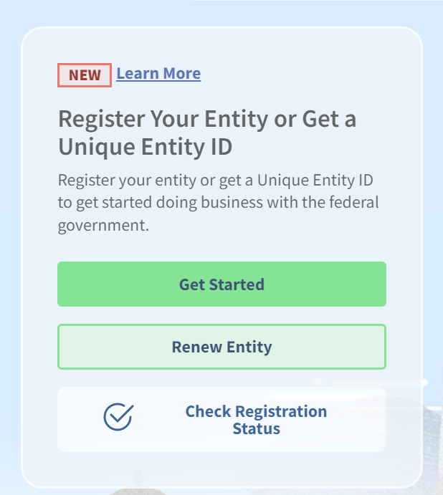

Once you click on the ‘Get Started’ tab, the website will walk you through the steps for completing the process. As mentioned above, it may take multiple weeks for the system to register your entity so it is advised to start this process as soon as possible.

KEY DISCLOSURES AND NOTICES:

- Full Application documents must be submitted to be considered for eligibility.

- The application documents contained herein do not commit City of Worcester to make an award, execute a contract, or pay for costs incurred in the preparation of said application, or to procure or contract for a program or service in connection therewith. The City of Worcester reserves the right to accept or reject any or all applications received, or cancel in part or in its entirety this program.

- The City may seek to obtain further information from any and all respondents and potentially waive any defects to form or content of application or any responses by the applicant.

- The City of Worcester, and thus any sub-recipients awarded ARPA funding through an executed contract as a result of a program, project or service stemming from this application process, are generally subject to the requirements of the Code of Federal Regulations, Chapter 2 Part 200 (2 CFR Part 200), except when certain exemptions are enumerated in the U.S. Treasury’s Final Rule.

  - Pursuant to 2 CFR 200.205, all RFP applicants may be subject to pre-award risk assessment as part of the City of Worcester’s overall decision making process related to making sub-awards stemming from this application process. The risk assessment may involve, at a minimum, evaluating risks posed by applicants related to the following parameters: financial stability, quality of management systems, ability to meet the management standards, and history of past grant performance, to include the applicant's record in managing prior Federal awards.

  - Pursuant to 2 CFR 180, prior to making any awards and contracts for ARPA funded programs or services, the City of Worcester will conduct suspension and debarment check to ensure any sub-awards and contracts are not executed parties that have been debarred, suspended or otherwise excluded from or ineligible for participation in Federal programs or activities.

- Applicants must abide by the City of Worcester’s Conflict of Interest policy.

- False statement or misrepresentations in application documents, or subsequent award contract documents, may automatically disqualify applicants and/or result in immediate repayment of federal funds to the City of Worcester.

- Upon submittal to the City of Worcester, all application documents become Public Record and property of the City of Worcester.
GENERAL APPLICATION INFORMATION

- APPLICANT INFORMATION

Organization Legal Name:

Organization Primary Address:

Primary Contact for Application (Full Name and Title):

Primary Contact Email:

Primary Contact Phone Number:

Active SAM Registration Number (Unique Entity Identifier):
Partner Organization(s)*
If applicable
Event Name and Event Date:

Event Location:

- NARRATIVE QUESTIONS

- Describe the mission of the applicant organization or partnership and the community it serves:

- Describe the event – what will take place? Who is the target audience and how many attendees are expected? How many times has this event taken place in the past? (OR is this a new event?)

- Does your event benefit or target audiences that qualify as Disproportionately Impacted Populations (as defined above)? If yes, please explain.

- STATEMENT OF APPLICANT

The undersigned acknowledges the following:

- That, to the best of its knowledge and belief, all factual information provided is true and correct and all estimates are reasonable.
- On submission of this application, the organization agrees to abide by the Federal regulations applicable to this program as well as the City’s locally established policies and guidelines.
- That a project’s funding does not guarantee its continuation in subsequent funding.
- Applicant shall provide written signatory authority from the organization’s governing body indicating who has authority to execute contracts and amendments on its behalf, prior to execution of the contract.
- Applicant agrees to abide by the City of Worcester’s Conflict of Interest policy. Items of concern would include staff members serving on the Board of Directors, staff members’ families serving on the Board of Directors, and other matters that may give the appearance of a conflict of interest.
- That, if the project(s) is funded, the organization will repay to the City any funds expended on costs consequently disallowed by the City or the Federal Government due to ineligibility based on programs rules and regulations.

By signature below, the applicant acknowledges the above on this |  | day of |  | ,2022.

Certifying representative for Applicant Signature |  | Title |  | Organization

- APPLICATION REQUIRED DOCUMENTS (Supplemental Attachments)

DOCUMENT | COMPLETED | Notes
Current List of Board of Directors (if applicable) | ☐
Event Budget | ☐
Copies of any Permits or Licenses (if applicable) | ☐
Most recent Financial Statement of Lead Organization | ☐
W-9 Form | ☐

- SUBMISSION

Applicants may submit electronic copies of the application via email to ARPA@worcesterma.gov

Hard copy submissions may be dropped off to Room 404, Worcester City Hall, 455 Main Street, Worcester, MA 01608.

Questions about this application can also be submitted via email to ARPA@worcesterma.gov

